

Model Development Phase Template
Model | Description | Hyperparameters | Performance Metric (e.g., Accuracy, F1 Score)
KNN | K-Nearest Neighbour got highest accuracy in our model | Best parameters: {'bootst rap': False, 'max_depth': 2 0, 'max_features': 'sqrt', ' min_samples_leaf': 1, 'mi n_samples_split': 10, 'n_es timators': 200} | 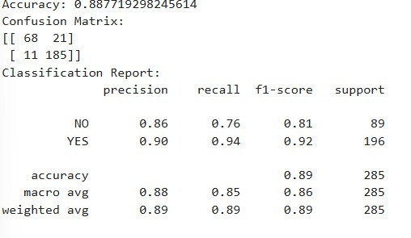

Date | 10 July 2024
Team ID | LTVIP2025TMID47084
Project Title | Revolutionising Liver Care- Predicting Liver Cirrhosis using advanced Machine Learning
Maximum Marks | 6 Marks

Model Selection Report
In the forthcoming Model Selection Report, various models will be outlined, detailing their descriptions, hyperparameters, and performance metrics, including Accuracy or F1 Score. This comprehensive report will provide insights into the chosen models and their effectiveness.

Model Selection Report:


XgBoost | We have used XgBoost with best parameters | Best parameters: {'colsa mple_bytree': 0.8, 'learni ng_rate': 0.01, 'max_dept h': 5, 'n_estimators': 200, ' subsample': 0.8} | 
      
    

